**Mechanistic Accretion Model Development for Gulf of Mexico**

The GCPLCC statement of work for this task states:

Depending on the data availability, the preferred accretion model choice is to implement the mechanistic Marsh Equilibrium Model version 3 (MEM3) developed by James Morris of The University of South Carolina. This model requires physical and biological input data such as marsh biomass and suspended sediment concentrations. These data will be collected from the EPA STORET database as well as local entities when available. The resulting model will be verified against the available accretion rates used in previous studies or reported in peer-reviewed literature. If available data do not support this approach, a second option is to implement simpler empirical functions that describe changes in measured accretion rates with respect to cell elevations and frequencies of inundation.

SLAMM accepts accretion rate data for each wetland type modeled. Accretion feedback models are most often applied to saltmarshes (regularly and irregularly-flooded) as these are where the majority of accretion data have been collected. In this study new feedbacks will be developed only for regularly-flooded marsh. This is due to data availability and also because the impact of inorganic sedimentation, which drives these feedbacks, is significantly less important above the mean higher high water (MHHW) level.

**Approach for Regularly-flooded marsh:**

The best types of data for an accretion-feedback analysis are accretion data points with corresponding elevations relative to tide levels. To meet this requirement, a database of 166 accretion measurements throughout the Gulf of Mexico was derived. One significant problem with this database was the assignment of locations to the various accretion studies. Very few studies report latitude and longitude along with their accretion data and in some cases no maps were included at all. When maps were available, approximate latitude and longitudes were assigned to each accretion study (Figure 1).

Elevation data were assigned to accretion data points based on best-available LiDAR data and converted to “mean tide level (MTL) basis” using the NOAA VDATUM product. In some cases, accretion rates were measured through long-term core data in which case the assumption that the marsh elevation has been in equilibrium with sea-level rise and tide ranges is required for the elevation derived to be relevant to the long-term accretion rate measured. There is considerable uncertainty in elevations assigned to accretion studies due to the temporal mismatch discussed above as well as horizontal errors (uncertainty as to the precise location being sampled) and vertical data errors (LiDAR uncertainty in marshes). Whenever possible “elevation change” data were used preferentially to “accretion rate” data to properly account for shallow subsidence effects within the data set.

Data from the farthest southeast corner of Louisiana were not included in this dataset as we have already developed and calibrated an accretion feedback model for this location. Furthermore, data from the “Bird’s Foot” were not assumed to be relevant to other locations in the Gulf of Mexico.

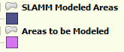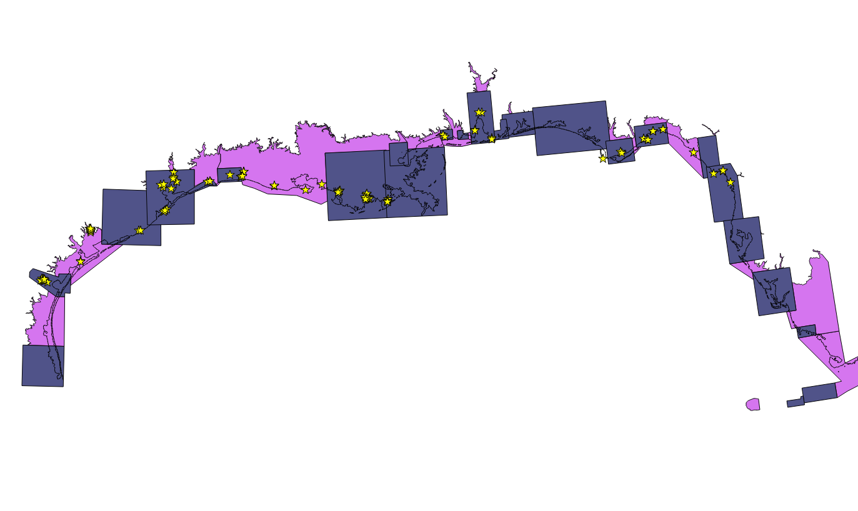

Figure 1. Accretion Locations (yellow stars) in Study Area which could be assigned locations

One important parameter for the MEM model is the average Total Suspended Solids (TSS) concentration. The EPA STORET database was queried to receive these data and a resulting dataset of 117,611 points was derived and spatially characterized throughout the study area.

Other required parameters for the MEM model include:

* Maximum peak biomass for the marsh
* Upper and lower limits of vegetation
* Organic matter decay rate
* Root & rhizome to shoot ratio
* Below-ground turnover rate
* Refractory fraction of belowground production
* Trapping coefficient for the vegetative matter in the marsh
* Settling rate for inorganic sediments in the marsh

Measurements for these parameters are rarely available and best estimates or professional judgments are required. Given uncertainty in these parameters, the MEM3 model is not tightly constrained unless sufficient calibration data are available to help define the model. Otherwise, with reasonable parametric inputs, maximum accretion rates can vary from 4 mm/year to 20 mm/year resulting in a fairly wide band of uncertainty for relationships between accretion rates and elevation.

The vast majority of data with relevant elevations were located in Louisiana and a MEM3 model was derived for this location. This model suggests that accretion rates will vary from 7.0 to 16 mm/yr depending on location in the tidal frame. A graph of this relationship and the data used to derive it is shown in Figure 2.

Figure 2. Derived MEM3 model with Louisiana-specific regularly-flooded marsh accretion data

Results from the derived model are quite similar to the calibrated accretion feedback used in SE Louisiana (Glick et al. 2013) in which accretion rates varied from 6 to 16 mm/year depending on location in the study area and in the tidal frame. We propose to apply this newly-derived MEM model to regularly-flooded marsh throughout new study areas in Louisiana which is where the data used to derive the relationship were derived.

To achieve this Louisiana-specific MEM3 model, the biomass range was extended to well above Mean Higher High water which is likely reasonable in this microtidal region. The organic matter contribution to accretion also was boosted to support relatively high accretion rates that data show occur at 0.5 meters above MTL and higher.

For other locations in the study area, accretion data with associated locations and elevations were too sparse to constrain a MEM3 model application. For example, in Florida, for regularly-flooded marsh, only five data points were found, all quite high in the tidal frame with relatively low accretion rates. This dataset, therefore, did not provide any insight into how accretion rates may increase under accelerated SLR (when the marshes move lower in the tidal frame).

One approach used in other study areas has been to derive a MEM3 model in a data rich area and then move this calibration into another location, varying only the TSS and tide range. We choose not to apply the calibrated MEM3 model shown above to regions outside of Louisiana, as Louisiana has often been considered to be fairly unique in terms of marsh characteristics. This is based on differences in organic matter content, suspended sediment supply, and the presence of floating marshes. For this reason it does not seem appropriate to derive a model with Louisiana-specific data and then apply this model throughout the Gulf of Mexico.

Based on these considerations, we propose an approach that takes into account measured accretion data, spatial variability in TSS data, and professional judgments to define a set of curves describing the relationship between accretion rates and marsh elevations. A “generic” accretion-to-elevation curve has been derived with the MEM3 model (Figure 3), and then minimum and maximum accretion rates can then be modified on the basis of local conditions.

The following accretion regions have been defined based on TSS:

* Southern Florida (South of Big Bend study area) - Mean TSS of 8 mg/L
* Northern Florida (Big Bend of Florida north) - Mean TSS of 10 mg/L
* Alabama, excluding Mobile Bay - Mean TSS of 11 mg/L
* Mobile Bay - Higher TSS (16 mg/L) and site-specific accretion data
* Mississippi - Mean TSS of 34 mg/L
* Louisiana - Calibrated accretion feedback in existing study areas and MEM model in non-modeled locations (Chenier Plain), TSS set to 26 mg/L
* Northern Texas (to Freeport) - Calibrated accretion feedbacks in existing study areas and MEM3 for Jefferson County, mean TSS of 30
* Freeport, Texas South to Mexican border - mean TSS of 36

TSS data presented above were derived first by querying individual data points from EPA STORET and then assigning these points to each defined study area (Figure 1). The top and bottom 2.5% of TSS data were discarded to remove the effects of significant outliers on central tendencies (to remove the effects of unique events that do not reflect the average TSS conditions affecting marshes). Study areas were combined and averaged to obtain a spatially weighted average TSS for each region. These data have been qualitatively considered, as part of the weight of evidence approach in determining reasonable accretion-feedback curves for each region.

For the southern portion of Florida, analysis of the accretion database created for this project indicates a minimum accretion rate of 0.8 mm/year and maximum measured accretion rates of 4.9 mm/year. This is consistent with regularly-flooded marsh accretion rates applied in Florida given previous SLAMM applications. It is also consistent with observations of TSS that are lowest among the accretion regions defined above. As increased SLR has not started to drown regularly-flooded marshes in this portion of the study area yet (at least in areas that we have accretion data), the upper bound accretion rate is uncertain. However, based on TSS availability it is safe to presume that it should be less than the 16 mm/year measured in Louisiana. Constraining the maximum accretion rate to the maximum accretion rate measured in the region seems like a reasonable conjecture. In the future, the uncertainty in the model based on this conjecture can be measured with a SLAMM uncertainty analysis. In addition, as will be the case for most study areas, additional observed data regarding marsh accretion rates at elevation (marsh organ studies), marsh biomass densities , and inorganic sediment settling rates can improve the accuracy of future SLR simulations. To summarize for S. Florida salt marshes we propose modeling with accretion feedbacks and minimum accretion rates of 0.8 mm/year and maximums of 4.9 mm/year.

Other accretion-region models are proposed below

* For Northern Florida, TSS concentrations increase relative to S. Florida as do maximum accretion rates observed. For this reason a similar relationship between accretion rates and elevations is assumed, but with the maximum accretion rate being set to 7.6 mm/year (maximum observed in the study area, measured by Leonard et al 1995) and minimum accretion rate set to 0.8 mm/yr (Cahoon et al. 1995 and Hendrickson 1997, net elevation change). Florida is the only portion of the study area with a useful database of elevation change data, measured by SET tables maintained by the Florida Geologic Survey. These data were provided to WPC in 2011 by Joe Donoghue in support of the Saint Andrew’s Choctawhatchee modeling effort funded by TNC. These rates cover the same range as previously applied to other SLAMM applications in this region (0.8 mm/yr in Apalachicola to 7.2 mm/yr in Southern Big Bend)
* For Alabama, excluding Mobile Bay, a maximum accretion rate is set to 6.8 mm/year based on somewhat lower TSS than Northern Florida and the accretion data of Callaway (1997). This value was applied without feedbacks to previous SLAMM applications in Mississippi.
* For Mobile Bay Alabama, the minimum accretion rate is set to 0.9 mm/yr and the maximum accretion rate to 11 mm/year (Smith and coworkers, 2013) based on the higher TSS observed in this region and observed accretion data cited above. The Smith reference also informed the previous application of SLAMM to Mobile Bay.
* For Mississippi, with much higher TSS measured than Alabama, an intermediate curve between Alabama and Louisiana is proposed, with a minimum rate of 3 mm/year and a maximum of 11.
* For the region of Southeastern Louisiana modeled by Glick and coworkers (2013), the calibrated accretion feedbacks will be maintained as previously applied.
* For new regions in Louisiana, the new MEM3 model derived as part of this project will be applied with accretion rates ranging from 7-16 mm/year based on measurements by Delaune et al. (1989) and Nyman and coworkers (1993). This range is slightly wider than the 6 to 11 mm/yr applied in SE Louisiana.
* For Northern Texas down to Freeport, calibrated accretion feedbacks in existing study areas will continue to be applied, ranging from 3.8-10 mm/year.
* For Southern Texas (below Freeport TX), the generic MEM curve will be adapted to the area based on a minimum accretion of 4.6 mm/yr (White et al. 2002) and a maximum of 8.4 mm/yr (Callaway et al. 1997).



Figure . Generic MEM3 curve

Table . Proposed accretion rate ranges to use in above curve

|  |  |  |  |
| --- | --- | --- | --- |
| **Location** | **Minimum Accretion rate (mm/yr)** | **Maximum Accretion rate (mm/yr)** | **Notes** |
| South FL | 0.8 | 4.9 | Lowest TSS region and measured accretion. |
| North FL | 0.8 | 7.6 | Higher TSS and measured accretion. |
| AL | 1 | 6.8 | Slightly lower TSS than N. FL. and observed. |
| Mobile Bay | 3 | 11 | Higher TSS and measured accretion |
| MS | 3 | 11 | Similar to non-Bird's Foot LA |
| SE LA | 6 | 16 | Calibrated, varies spatially |
| LA Chenier Plain | 7 | 16 | MEM3 calibration (Figure 2) |
| Jefferson Co. TX | 6 | 12 | Intermediate between LA and Galveston Bay |
| Galveston Bay | 3.8 | 10 | Calibrated previously |
| Freeport to MX border | 4.6 | 8.4 | Lower TSS, and based on Callaway (1997) |

**Approach for wetland categories without feedbacks:**

Irregularly-flooded marshes:

For Irregularly-flooded marsh the MEM3 model provides somewhat fewer insights as the effect of inorganic sedimentation, so important to MEM3 predictions, is relatively unimportant above the mean higher high water (MHHW) level. In other words, the feedback between irregularly-flooded marshes and their elevations is less important as the tidal flooding which drives this process is much less regular. For this reason, we do not plan to use the MEM3 model to model irregularly-flooded marshes for this application and instead will rely on average accretion rate data as has been done in previous model applications.

Mangrove

Elevation change data collected in Florida suggests an accretion rate of 2 mm/yr (Cahoon and Lynch 1997; Donoghue 2011; McKee 2011). This is lower than the rates of 7 mm/yr and 3.3 mm/yr previously applied in the gulf; however, it is more appropriate since SLAMM tracks elevation change.

Regarding mangrove distribution, we will model mangroves in Florida up to Tampa Bay based on previous SLAMM applications and the findings of Osland and coworkers (2013). When the SLAMM model finds adequate mangrove coverage in a site, it designates that site as “tropical” and all wetland to wetland or dry land to wetland conversions become mangroves. Therefore, mangroves tend to dominate these sites under conditions of SLR. In Florida, north of the Tampa Bay study area, previous SLAMM applications were not designated as “tropical.” It is certainly possible that mangroves will continue to migrate further north in the next 85 years and this is not represented by these simulations. The northern boundary of mangrove habitat tends to be driven by the “hard freeze” line and air temperature is not a driving variable within SLAMM applications. Furthermore, the boundary of mangrove habitat is patchy and uncertain and can be variable from year to year. No mangrove expansions in Texas, Louisiana, MS, or AL are predicted by this modeling exercise, either, consistent with previous applications of SLAMM in those states.

Tidal and Inland Fresh Marsh

A gap analysis will be used to apply accretion rates to unmodeled areas: The values applied to adjacent areas will be extrapolated based on site characteristics and professional judgment.

Swamp and Tidal Swamp

For all previous Gulf SLAMM analyses, excluding the Atchafalaya Basin, swamp and tidal swamp accretion rates were set to 0.3 and 1.1 mm/yr, respectively. Due to a lack of data to determine more appropriate site-specific rates, and to maintain consistency with previous model applications, we will also apply these rates to gap areas.

**References**

Cahoon, D. R., and Lynch, J. C. (1997). “Vertical accretion and shallow subsidence in a mangrove forest of southwestern Florida, USA.” *Mangroves and Salt Marshes*, 1(3), 173–186.

Callaway, J. C., DeLaune, R. D., and Patrick, Jr., W. H. (1997). “Sediment Accretion Rates from Four Coastal Wetlands along the Gulf of Mexico.” *Journal of Coastal Research*, 13(1), 181–191.

DeLaune, R. D., Whitcomb, J. H., Patrick, W. H., Pardue, J. H., and Pezeshki, S. R. (1989). “Accretion and canal impacts in a rapidly subsiding wetland. I. 137Cs and210Pb techniques.” *Estuaries*, 12(4), 247–259.

Donoghue, J. (2011). Personal Communication, “SET question.”

Glick, P., Clough, J., Polaczyk, A., Couvillion, B., and Nunley, B. (2013). “Potential Effects of Sea-Level Rise on Coastal Wetlands in Southeastern Louisiana.” *Journal of Coastal Research*, Understanding and Predicting Change in the Coastal Ecosystems of the Northern Gulf of Mexico, Special Issue No. 63, 211–233.

McKee, K. L. (2011). “Biophysical controls on accretion and elevation change in Caribbean mangrove ecosystems.” *Estuarine, Coastal and Shelf Science*, 91(4), 475–483.

Nyman, J. A., DeLaune, R. D., Roberts, H. H., and Patrick Jr, W. H. (1993). “Relationship between vegetation and soil formation in a rapidly submerging coastal marsh.” *Marine ecology progress series. Oldendorf*, 96(3), 269–279.

Osland, M. J., Enwright, N., Day, R. H., and Doyle, T. W. (2013). “Winter climate change and coastal wetland foundation species: salt marshes vs. mangrove forests in the southeastern United States.” *Global change biology*, 19(5), 1482–1494.

Smith, C. G., Osterman, L. E., and Poore, R. Z. (2013). “An Examination of Historical Inorganic Sedimentation and Organic Matter Accumulation in Several Marsh Types within the Mobile Bay and Mobile-Tensaw River Delta Region.” *Journal of Coastal Research*, 63(sp1), 68–83.

White, W. A., Morton, R. A., and Holmes, C. W. (2002). “A comparison of factors controlling sedimentation rates and wetland loss in fluvial-deltaic systems, Texas Gulf coast.” *Geomorphology*, 44(1-2), 47–66.